AppLCC/Wheeler NWR Partners Workshop
For detailed meeting info click HERE

Wheeler National Wildlife Refuge – Visitors Center
March 2nd / 8:00 AM – 4:30 PM

Purpose: To truly be successful in conserving natural resources we must work to maximize the efficiency and effectiveness of our efforts. To achieve this, it is essential we plan and work at the landscape level and engage a diversity of partners to leverage resources and chart a route forward. The purpose of this workshop is to familiarize participants with the Appalachian LCC and its efforts and resources available that can aide participants’ efforts to enhance efficiency and effectiveness of their local and regional conservation planning efforts.

2nd March 8:00 – 4:30

Objective: Participants will gain knowledge of the landscape-level approach to conservation planning, be able to identify how their efforts fit into this “bigger” picture, and understand the utility and process to apply AppLCC resources to their conservation planning efforts.

Morning Session:
- Introduction to LCCs and the Big Question: “Why.” Launching a National Landscape-level Conservation Planning Approach to Conservation

- Facilitated group discussion - Landscape level conservation planning and how it relates to participants current local or regional efforts

- Examples of several AppLCC resources that can be used to help answer/guide management questions/actions - This session will be tailored to workshop participants via feedback during RSVP process.

- Case study session – participants will apply information from a tailored case study to develop a strategy for utilizing AppLCC tools as part of a decision management process - This session will be tailored to workshop participants via feedback during RSVP process.

Lunch (on own/ off-site or brown bag)

Afternoon Session:
- How people are integral to our efficiency and effectiveness - examples of AppLCC resources that can help broaden constituents and strengthen collaborative efforts/leverage resources.

- The 2nd Big Question – What is a (Regional) Landscape Conservation Design (LCD) and how does this inform FWS and partners planning and working at smaller-scale units?

- Facilitated group discussion - How AppLCC resources can help to make participants work more efficient and effective and how participants may apply them in their own work.

- How to improve Modeling Targets in LCD – AppLCC would like your input as to how the LCD could be more inclusive of waterfowl and wading bird conservation planning needs.

BIOGRAPHIES

Gillian Bee, LCC Landscape Conservation Fellow
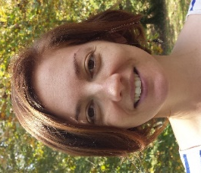
Gillian Bee is the new Appalachian LCC Landscape Conservation Fellow, stationed at Clemson University. In her current role, she will be working with partners in the Tennessee River Basin to provide science-based decision support. Prior to her new role, Gillian was the Stewardship Director for the Bird Conservancy of the Rockies. For the past five years, she has focused her efforts on the collaborative conservation of private working lands. She is passionate about building relationships that encourage proactive conservation for natural resources and rural culture. Gillian received her bachelor’s in wildlife biology from the University of Vermont and her master’s in wildlife biology from Clemson University.

Jean Brennan, LCC Coordinator & Chief Scientist
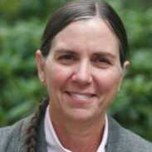
Dr. Jean Brennan is the Coordinator and Chief Scientist/Science Coordinator for the Appalachian LCC where she has served since 2010. As an ecologist she has worked extensively internationally, conducting research on primates in Kenya; carnivores on Madagascar; Asian elephants and other endangered large mammals on Peninsula Malaysia; and orangutans and proboscis monkeys on Borneo, Indonesia. She holds graduate degrees in Population Biology and Genetics from the University of Tennessee; Forest Ecology from Yale University School of Forestry; and Anthropology from the University of Pennsylvania. She has taught “Conservation Biology” at the University of Michigan, School of Natural Resources and Environment, and “Air Resources” at the University of California Davis.

Before joining the U.S. Fish and Wildlife Service, Jean worked as a Senior Climate Change Scientist, most recently with a DC-based environmental NGO, and previously as a Senior Conservation Scientist for the U.S. Agency for International Development. Jean also served as a staff scientist for the U.S. State Department, Office of Global Change. Her work as a member of the U.S. Delegation to the Intergovernmental Panel on Climate Change (IPCC) earned her recognition and she was recognized for her contributions and selected by the IPCC to share the honor the 2007 Nobel Peace Prize. Her current interests focus on the application of science at a landscape-scale and synthetic research into the impacts and adaptation to climate- and major land-use change.

Matthew Cimitile, Communications Coordinator
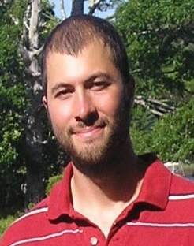
Matthew Cimitile is the Communications Coordinator for the Appalachian LCC where he has served since 2012. Matthew worked for the USGS St. Petersburg Coastal and Marine Science Center prior to joining the Appalachian LCC team as a writer and multimedia specialist where he produced press releases, feature articles, online content, and helped develop a video podcast series that went on to win a USGS Shoemaker Award in audio and visual communications. Matthew earned a bachelor’s degree at the University of Tampa and a master’s in environmental journalism at Michigan State University. During his time at Michigan State, Matthew interned with The Nature Conservancy, Environmental Health News, and was part of the initial team that started the environmental reporting website Great Lakes Echo

